Design of a Ground Rover with TI mmWave Radar Sensor for Geographical Acquisition in Disaster Rescue Applications
*Note: Sub-titles are not captured in Xplore and should not be used

Jesudara Omidokun
Dept. of Business and Engineering
University Of Maryland Eastern Shore
Princess Anne MD, USA
Aduralere Sulaiman
Dept. of Business and Engineering
University Of Maryland Eastern Shore
Princess Anne MD, USA.
Lei Zhang
Dept. of Business and Engineering
University Of Maryland Eastern Shore
Princess Anne MD, USA

Abstract— As technology continues to advance, the applications have become ubiquitous. One of the fields in which technology has made a lot of advancements over the past years is in disaster relief, and search and rescue operations. Robots and drones can be utilized in places that might be hazardous to humans. The robots and drones can also be used to guide rescuers or provide valuable data (such as data about an area), or even provide some form of communication services.
The main component of the ground rover is the mmWave radar sensor which was developed by TI. The mmWave sensor is an extremely valuable sensing technology for the detection of objects and providing the range, velocity, and angle of these objects. It is a contactless-technology which operates in the spectrum between 30GHz and 300GHz. Due to the technology’s use of small wavelengths, it can provide sub-mm range accuracy and is able to penetrate certain materials such as plastic, drywall, clothing, and is impervious to environmental conditions such as rain, fog, dust and snow. The mmWave sensor has a clear advantage over other sensing technologies such as ultrasonic sensors and LIDAR. It has a long detection range, narrow and wide detection angle, good range resolution, and has good night operation performance. The purpose of the project is to design a rover that can acquire geographical acquisition such as the range, velocity, angle and 3D imaging of objects in an unknown area.
Robin Murphy, head of Center for Robot-Assisted Search and Rescue (CRA SAR), says; “The impact of earthquakes, hurricanes, flooding is increasing, so the need for robots for all phases, from prevention to response and recovery, will increase as well.”

Introduction (Heading 1)
The world we live in today is a scary one where natural disasters occur almost every day. One of the most common natural disasters that occurs frequently is earthquakes. The natural disaster that occurred in recent years which actually motivated the project was the 2010 earthquake that occurred in Haiti. A magnitude-7.0 earthquake struck Haiti on the afternoon of January 12, 2010, and was one more disaster in a country that had suffered from decades of political, economic, and social setbacks and inequalities. This earthquake was the most devastating natural disaster that the country had experienced. Approximately, 3 million people were affected with roughly 250,000 lives lost and 300,000 people injured. About 1.5 million individuals were forced to live in makeshift internally displaced person camps. This natural disaster was the main motivation behind our project. The mmWave sensor is an extremely valuable sensing technology for the detection of objects and providing the range, velocity, and angle of these objects. It is a contactless technology that operates in the spectrum between 30GHz and 300GHz. Due to the technology’s use of small wavelengths, it can provide sub-mm range accuracy and is able to penetrate certain materials such as plastic, drywall, clothing, and is impervious to environmental conditions such as rain, fog, dust, and snow. The mmWave sensor has a clear advantage over other sensing technologies such as ultrasonic sensors and LIDAR. It has a long detection range, narrow and wide detection angle, good range resolution, and has good night operation performance. The mmWave sensor on the rover can provide 3D point cloud information on the building where the situation occurred. It will also work better than a camera because of its long detection range, it’s narrow and wide detection angle, as well as it is good range resolution. From the 3D point cloud information provided by the mmWave sensor, the rover would be able to provide the best possible route for the officers to avoid obstacles. The objective of the project is to design a rover that can acquire geographical information such as the range, velocity, angle and 3D imaging of objects in an unknown area.
An example of a robot capable of disaster rescue is the CHIMP robot designed by Carnegie Mellon University’s National Robotics Engineering Center. Another example is the Momaro robot which has been specifically designed by the team NimbRo Rescue from the University of Bonn in Germany.
Figures 1 and 2 below show the Momaro and NimbRo Rescue that can be used in disaster rescue applications.
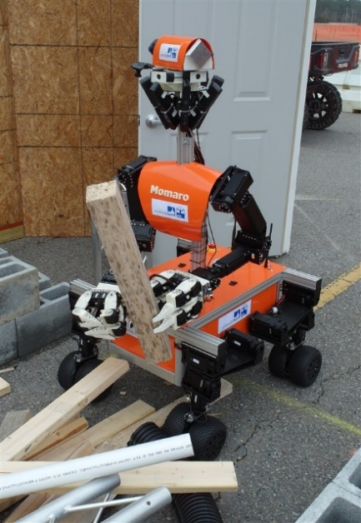
- Momaro Robot Used in Disaster Rescue
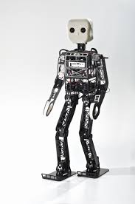

- NimbRo Robot

Method

Objectives
The objective of the project is to design a rover that can acquire geographical information such as the range, velocity, angle and 3D imaging of objects in an unknown area.

Design requirements
- The device will be able to visualize data (provide point cloud information).
- The device will be able to avoid obstacles while providing autonomous navigation
- The payload of the car will be 15 to 20lbs
- The device will detect an object within the range of 3cm to 10 m.
- The device will have a resolution range of 10cm.

Design Method
The first step for this design is to solder, assemble, and wire the Robotic rover running on a Ti microcontroller MSP432p401 and raspberry pi 4. The second step was to install a motor drive L298N to control four motors installed on the rover. The next step was to install an operating system on raspberry pi. TI recommended Ubuntu operating system because the robotic operating system libraries which are needed for navigation and point cloud system only support Ubuntu 16.04 64bit at present. Furthermore, A power supply is to be design to generates 5 Volts and 2.5 Amp to power on the mmWave. Moving on, the interfacing process will be introduced to implement the mmWave interface with the microcomputer. In continuation, the Robotic operating system(kinetic) will be installed on the Pi and a workspace will be created to save all code and launch files need to run the robotic and generate the point cloud data. Afterward the next is to acquire the point cloud data from the radar using the microcomputer by launching the TI mmWave_rospkg node to start the mmWave IWR1443 BOOST EVM. stitch the 3D point cloud data generated. The point will then use for the autonomous navigation of the rover. The next step is to implement object detection behind a glass wall and vary it with different wall and angle the object is placed relative to the mmWave. Finally, all system finalization, testing, and refinement.

Procedure

Installation of ROS and all other necessary packages
The ROS kinetic Kame was selected among the two distribution that is commonly used now. The prerequisites for install ROS kinetic kame are installed bootstrap dependencies, installing ROSDEP. The Installing Building the catkin Packages, Create a catkin workspace, Set up your keys, Install a Debian package that contains(ROS, rqt, rviz, robot-generic libraries, 2D/3D simulators, navigation, and 2D/3D perception and Environment setup under the ROS Workspace note install the rosbuild Not catkin.
The process for installing the Operating System is as follows:
- Install the ROS ‘serial’ package:
- Use GIT to download (clone) the ROS serial driver into your /src directory: $ cd /src $ git clone https://github.com/wjwwood/serial.git. More documentation on this library can be found at http://wjwwood.io/serial/ TI mmWave ROS Driver Setup Guide Version 1.5 6 3.
- Download the TI mmWave ROS Driver (ti_mmwave_rospkg) and copy it to your /src.
- After opening the ti_mmave_rospkg_.zip file, see the ti_mmwave_rospkg. Open a new file browser and navigate to your /src directory. Copy the ti_mmwave_rospkg folder to the /src directory.
- Build your project: In the Terminal/shell, go to your directory and build the driver: $ cd $ catkin_make.
- Flash the mmWave using the UniFlash
- Launch the TI mmWave ROS node and Rviz visualizer by running $ rosrun rviz rviz.
The ROS Kinetic Kame was supposed to be used because most of the ROS mmWave library was design for the ROS Kinetic Kame but the ROS Kinetic Kame cannot be installed on ubuntu 18.04 only 16.04 so the new ROS package was installed ROS Melodic Morenia.
The ROS Melodic Morenia was selected among the two distribution that is commonly used now. Visit for the installation http://wiki.ros.org/melodic/Installation. The prerequisite to install ROS Melodic Morenia was to install bootstrap dependencies, installing ROSDEP. Install the catkin Packages, Create a catkin workspace, Set up your keys, Install a Debian package that contains(ROS, rqt, rviz, robot-generic libraries, 2D/3D simulators, navigation, and 2D/3D perception and Environment setup under the ROS Workspace note install the catkin. Finally, install Ros serial package.

Generating the Point Cloud Data
To generate a point cloud from mmWave with a Robotic Operating System, the following requirements are needed:
- Host PC (laptop or desktop)
- TI mmWave 1443 ES3.0 EVM
- USB to micro-USB cable
- 5VDC power supply (center positive barrel jack, 2.5A)
- Ubuntu 16.04 LTS operating system
- Robot Operating System (ROS)
- ti_mmwave_rospkg source code
- mmWave SDK software
- UniFlash
- The steps to visualize the point cloud data are as follows:
- Install bootstrap ROSDEP on PC
- Install ROS kinetic kame
- Create Workspace
- Create the ROS workspace environment
- Install ti_mmwave_rospkg_zip ROS driver
- Flash mmWave using UniFlash
- Import radar file provided by TI
- Generate the point cloud data using rosrun rviz rviz
Before visualizing the point cloud data on the ROS Visualizer, some parameters can be tweaked to improve the point cloud data and save in the workspace to replace the existing one. Some of these parameters are:
- Range Resolution
- Frame Rate
- Maximum Radial Velocity
- Radial Velocity Resolution
See Figures 3 and 4 in the Result session.

Results
Based on the procedure of the 3D point cloud, the 3D point cloud data was generated by a mmWave sensor. The Data can be visualized in real-time using the ROS visualizer. There is some parameter that still need to be changed apart from the once discussed in the procedure, Some of these parameters are Range Resolution, Frame Rate, Maximum Radial Velocity and Radial Velocity Resolution. The figure below shows the parameters of the visualizer that can be tweaked to improve the visualization of the point cloud data.
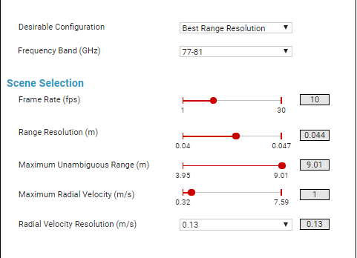
- The parameter involve point cloud data
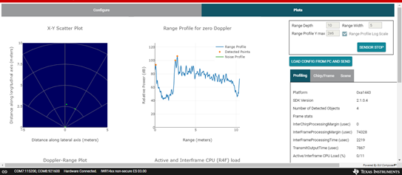

The figures 5 and 6 below show the ROS visualizer and the visualizer showing the 3D point cloud data of a particular environment.
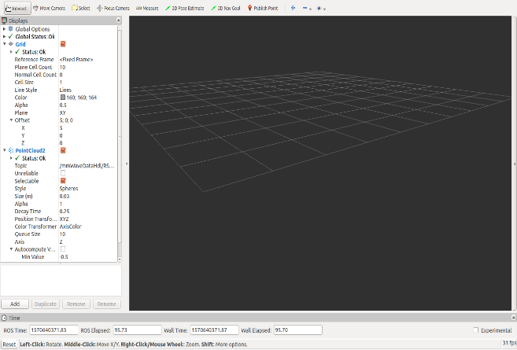
- Fig. ROS Visualizer
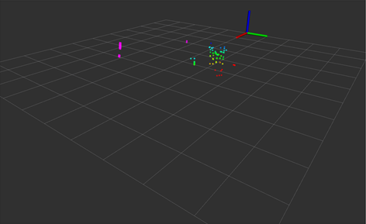
- ROS Visualizer with point cloud data

Conclusion
Working on this design project was an unforeseeable journey. A lot was learned while working on this project. There were a lot of uncertainties down the line. Working with a microcomputer and the mmWave sensor proved to be difficult. For the project, the right microcomputer had to be used so that the mmWave sensor would interface smoothly with the microcomputer. An ODROID XU4 was initially purchased to perform as the microcomputer. However, this proved to be too difficult to use. A PINE A64 was then purchased but there will still many complications. As the mmWave uses many of TI’s nodes which had to be downloaded using chrome, the PINE A64 proved to be almost useless. Eventually, after a lot of tries and errors, we stumbled upon the raspberry pi 4.The raspberry pi 4 proved to be very adequate but difficult as it is still a fairly new microcomputer and there is still a lot of unreleased information.
Working with the mmWave sensor was also a hassle as it is also still a fairly new technology. There was a little assistance from TI as they helped replace a sensor that stopped working in the previous semester. However, when it came to some information or aid about the sensor, they couldn’t help too well and a lot had to be figured out.
A lot was learned during the course of this project which was very exciting. One section about the project that was very interesting was the many uses of ROS. Hopefully one day, there will be more opportunities to work on robots and ROS.

Acknowledgment
The preferred spelling of the word “acknowledgment” in America is without an “e” after the “g”. Avoid the stilted expression “one of us (R. B. G.) thanks ...”. Instead, try “R. B. G. thanks...”. Put sponsor acknowledgments in the unnumbered footnote on the first page.

Reference
- Zeldovich, Lina. “These Rescue Robots Can Tackle Almost Any Disaster, Part 2.” ASME.org, Feb. 2019, www.asme.org/engineering-topics/articles/robotics/rescue-robots-can-tackle-almost-any-disaster-part.
- Zeldovich, Lina. “The 7 Coolest Rescue Robots Tackle Almost Any Disaster, Part 1.” ASME.org, Feb. 2019, www.asme.org/engineering-topics/articles/robotics/7-coolest-rescue-robots-tackle-almost-any.
- Underwood, Kimberly. “DHS, NIST Standards for Rescue Robots Gain Momentum.” SIGNAL Magazine, 3 Oct. 2018, www.afcea.org/content/dhs-nist-standards-rescue-robots-gain-momentum.
- Faggella, Daniel. “11 Robotic Applications for Search and Rescue.” HuffPost, HuffPost, 23 Nov. 2017, www.huffpost.com/entry/11-robotic-applications-for-search-and-rescue_b_5a173c9ae4b0bf1467a845c4.
- http://www.ti.com/product/IWR1443

